Comment on Analysis note ([Link](https://aliceinfo.cern.ch/Notes/sites/aliceinfo.cern.ch.Notes/files/notes/analysis/aborisso/2017-Aug-11-analysis_note-Sigma0-note-2010ppPass4data-15jan16.pdf))

Label

**Blue**: simple (just remove or change)

**Green**: need to check and discuss/correct

**Red** : most critical one (Number: event, mass, width, dN/dy, <pT>) and the thing we may prepare answer to IRC

Note that draft_v3.pdf means file that IK. Yoo sent April 18th.

1. **L61**: recommend removing “Is the cross section ratio 0☹= 0.33 at LHC energies?”  
- I think this sentence is unnecessary. It would give bias on results

2. **L73**: recommend removing “Note measurement of 0 polarization in p-Be collisions at intermediate energies “  
- I think this sentence is unnecessary since we don’t say of 0 polarization as results

3. **L74**: recommend removing “0 is an additional observable for the enhancement of strange baryon production at very high multiplicity in pp data at 7 and 13 TeV “  
- I think this sentence is unnecessary since we don't show results from multiplicity dependent analysis.

4. **L104**: remove “542 million events” or change it to 428 million minimum-bias events since in Appendix 11.1, 428 million events is selected as MB events.  
*** Correspondently, L95 in draft_v3.pdf needs to be changed.   
- draft_v3: A total amount of about 500 million  MB events has been utilized for the analysis.    
- 500 million MB events 🡪 428 million MB events

5. **Regarding Appendix 11.1**  
- I think it is too much detail. Instead of tables in Appendix 11.1, we can directly give information of number of MB in Section 1.6 (Event selection)  
- If IRC ask to comparison of event selection for Sigma0 and PCM, we can provide it.  
- If we want to keep it as it is, we need to explain about definition of NMB, NNORM, NOUT, NNVXCNTR and so on in the Table4.

6. **L187**: V0OR trigger hit in either of two VZERO detectors.  
- MBOR trigger requests, hit on V0OR or SPD  
- give same information which is written in draft_v3.pdf

7. **Figure2**: Armenteros-Podolanski distribution of Sigma0  
- I would like to remove this figure.   
- If we want to show them, we need to provide also distributions of before cut.  
- Distribution of Sigma0 in data and MC is different. Sigma0 in Data seems two maximum curves while MC shows one maximum curve.

8 **L209**: definition of alpha  
- It should not be absolute value. Look on Fig4.

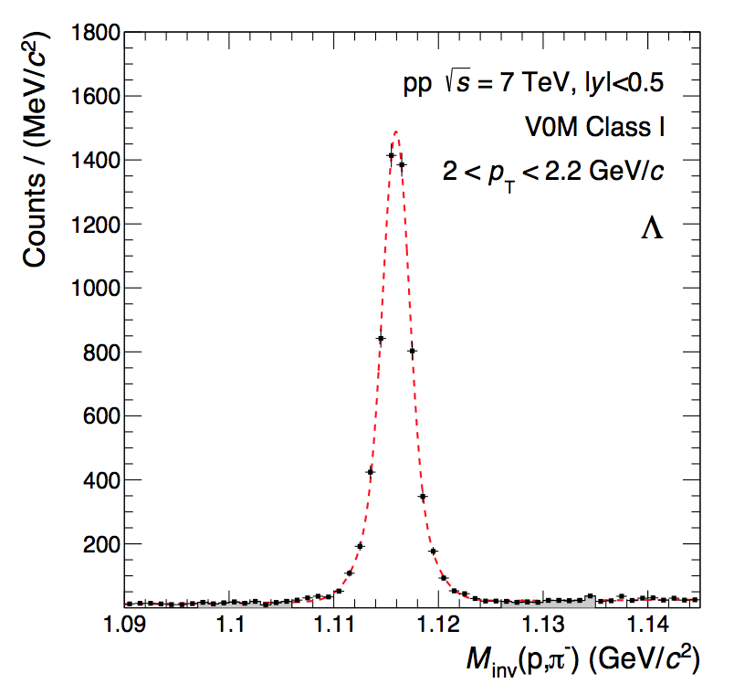9. **Fig.3**: regarding the invariant mass of Lambda   
- Significance of Lambda signal is quite poor than I expected  
- See distribution of Lambda in 2018-Apr-02-paper_draft-PidSpectraVsMultLong.pdf  
- IRC may ask the reason and we may prepare the answer

10. **regarding Lambda selection**- We need to add “DCA between Lambda daughters”   
- It is listed in Section 7.1 as “LambdaDCADaughters” but it is omitted here.  
- Check the cut value and write.

11. **L244**: “the mean energy of photo is <E> ~ 100 MeV  
- How to calculate/estimate it? We need description of it.

12. **L264**: add symbol for absolute sign

13. **L265**: check the acceptance of ϕ   
- is it really 0 to 6.28 ?

14. **L283**: add unit (same for L284)

15. **Fig.6**: Left figure, do we understand the bump at 0.2 GeV/c2 ?

16. **L329**: mean fitted value of Sigma0 mass M = 1.19282 +- 5.7535e-05  
- Same information is written as 1192.94 +- 0.035 in draft_v3.pdf in L166.  
- Which one is correct one?  
- Even though it is small difference, we have to explain.

17. **Fig.12** : Mean and sigma of Sigma0  
- recommend to add pol(0) fit on the figure  
- from the fit results, we correct the mean and sigma value in draft_v3 around line 166 to 171

18. **L343**: “reconstructed Gauss fit of invariant mass…”   
- Maybe “reconstructed number of Sigma0 to generated number of Sigma0” instead of Gauss fit.

19**. Chapter 5.** Comparison of results from pass2 and pass4  
- May we remove Chapter 5?   
- I think we can keep as backup since nobody expects that there is different physics between pass2 and pass4.

20. **L419**: LambdaK0sDiff  
- This information is not mentioned in draft_v3  
- If it is not used for Sigma0 analysis, we might remove it.

21. **L420**: LambdaDCADaughters  
- This information is not mentioned in draft_v3.  
- I know this cut is used for V0 selections when V0s are reconstructed and we need to add it to draft_v3.

22. **L443**: Detailed systematic studies with around ~100 times larger statistics…  
- Why it has difference about 100 times statistics?

23. **Fig20**: Example of variation of cut on DCA to PV  
- In the systematic study for DCA to PV, if I follow the Appendix 11.4 (systematic studies of Lambda detection), the cut value applied was > 0.06 cm while the cut value has been tested on Fig20 is < 40, 10, 8, 6, 4, 2 cm.  
- Which one is correct cut value?  
- If the figure shows variation of cut on DCA to PV, it has to have comparison between >0.06cm to the other values because >0.06 is default cut.

24. **L459**: Nσπ (also L469)  
- Why do we need this cut? We need to explanation of it.  
- it is also not mentioned in draft_v3  
- if we do not use it, we can remove

25. **L469**: Fig.22 in data and Monte Carlo samples  
- Fig22 does not contain information of MC sample

26. **Equation (3) σsyst**.  
- We need to check if there is contribution from Global tracking efficiency and hadronic interaction.  
- Ref.23 contains also systematic uncertainty due to GEANT3/FLUKA correction. We need to check it whether it is needed for Sigma0 analysis.

27. **Fig22**: regarding the variation of minimum pT for electron  
- The variation was done with > 0.5 GeV/c to 0.75, 0.8, 0.85, 0.9 and 0.95 GeV/c  
- The results with 0.9 and 0.95 GeV/c cut give quite large systematic uncertainties compared the systematic uncertainties of gamma analysis in Fig.23 right panel  
- I guess the cut value of 0.9 and 0.95 GeV/c is too large deviation because the gamma for Sigma0 needs to have small energy about 77 MeV/c2.  
- IRC may ask to remove or change the cut value and see the results or ask to check the cut value used for PCM analysis

28. **Equation (4)**: definition of Levy-Tsallis fit function  
- In draft_v3.pdf, 1/Ninel is omitted   
- we need to provide same information

29. **L537**: regarding the variation of fit function on pT-spectra  
- So far, we have tested with Boltzmann, pT, mT and Bose-Einstein fit function but it is not included as systematic uncertainty due to poor fit results based on Xi2/NDF.  
- IRC may ask to fit with restricted range to see the results

30. **L542**: check the value of dN/dy  
- AN: 0.290+-0.0072  
- Draft_v3: 0.0256+-0.083

31. **L255**: check the value of <pT>  
- AN: 1.1369+-0.0810  
- Draft_v3: 1.161+-0.085

32. **Table1**: check the dN/dy , <pT> as well as fit parameters

33. **L585**: Sigma0 to Lambda ratio  
- AN: 0.380 +- 0.098  
- Draft_v3: 0.337 +- 0.111